1)Pre-Build Docker image is available on docker hub. It contains all the required software to run the application:

Software Included:

Tomcat 8

Oracle JDK 8

Starbucks.jar

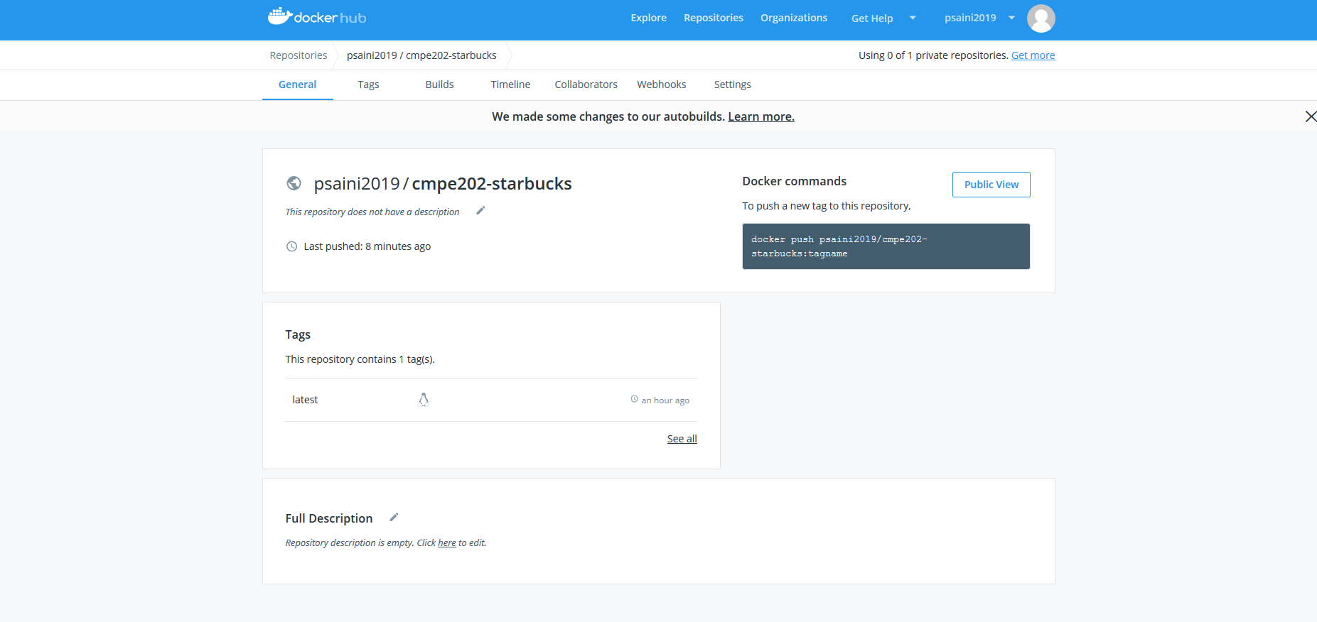

2) ECS cluster and application load balancer is created to deploy docker/container on AWS. It is up and running and load balanced using application load balancer:

URL: <http://ec2co-ecsel-7fuzyg65c2px-1340953552.us-west-1.elb.amazonaws.com:8080/starbucks/webapi/starbucks/>

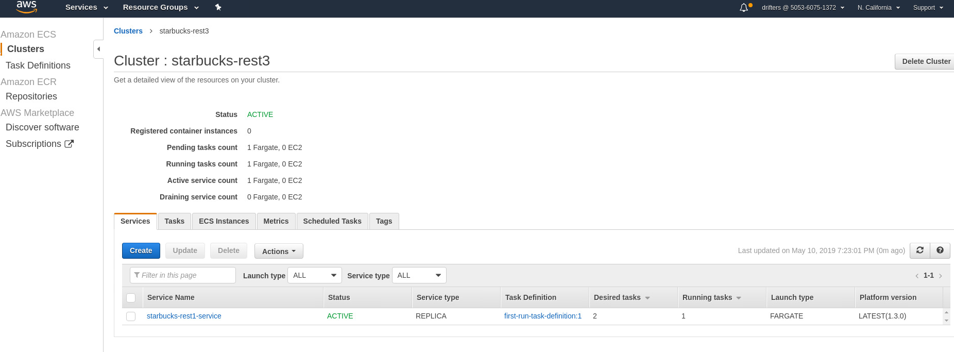

We have 2 desired service counts are running and load balanced using application load balancer

